

Semester One Examination, 2020

Question/Answer booklet

MATHEMATICS

If required by your examination administrator, please place your student identification label in this box
APPLICATIONS
UNIT 3

Section One:

Calculator-free

WA student number: In figures

In words

Your name

Number of additional
answer booklets used
(if applicable):

Time allowed for this section
Reading time before commencing work: five minutes
Working time: fifty minutes

Materials required/recommended for this section
To be provided by the supervisor
This Question/Answer booklet
Formula sheet

To be provided by the candidate
Standard items: pens (blue/black preferred), pencils (including coloured), sharpener,
correction fluid/tape, eraser, ruler, highlighters

Special items: nil

Important note to candidates
No other items may be taken into the examination room. It is your responsibility to ensure that you do not have any unauthorised material. If you have any unauthorised material with you, hand it to the supervisor before reading any further.

Structure of this paper

Section | Number of  questions  available | Number of  questions to  be answered | Working  time  (minutes) | Marks  available | Percentage  of  examination
Section One:  Calculator-free | 8 | 8 | 50 | 52 | 35
Section Two:  Calculator-assumed | 13 | 13 | 100 | 98 | 65
 |  |  |  | Total | 100

Markers use only
Question | Maximum | Mark
1 | 6
2 | 6
3 | 6
4 | 7
5 | 6
6 | 7
7 | 7
8 | 7
S1 Total | 52
S1 Wt (×0.6731) | 35%
S2 Wt | 65%
Total | 100%

Instructions to candidates

1. The rules for the conduct of examinations are detailed in the school handbook. Sitting this examination implies that you agree to abide by these rules.

2. Write your answers in this Question/Answer booklet preferably using a blue/black pen.
Do not use erasable or gel pens.

3. You must be careful to confine your answers to the specific question asked and to follow any instructions that are specific to a particular question.

4. Show all your working clearly. Your working should be in sufficient detail to allow your answers to be checked readily and for marks to be awarded for reasoning. Incorrect answers given without supporting reasoning cannot be allocated any marks. For any question or part question worth more than two marks, valid working or justification is required to receive full marks. If you repeat any question, ensure that you cancel the answer you do not wish to have marked.

5. It is recommended that you do not use pencil, except in diagrams.

6. Supplementary pages for planning/continuing your answers to questions are provided at the end of this Question/Answer booklet. If you use these pages to continue an answer, indicate at the original answer where the answer is continued, i.e. give the page number.

7. The Formula sheet is not to be handed in with your Question/Answer booklet.
Section One: Calculator-free 35% (52 Marks)
This section has eight questions. Answer all questions. Write your answers in the spaces provided.

Working time: 50 minutes.

Question 1 (6 marks)
Consider the following graph $G$.
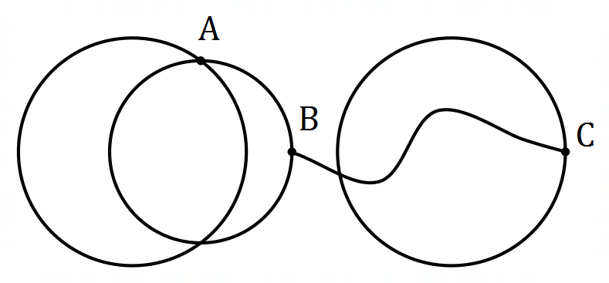

(a) Draw $G$ in the plane, to clearly show that it is planar. (2 marks)

(b) State the degree of each vertex and the degree sum for $G$. (2 marks)

(c) Explain how to recognise a bridge in a connected graph and state, with justification, whether $G$ contains a bridge. (2 marks)

Question 2 (6 marks)
A recursive rule for a sequence is $T_{n+1}=T_{n}-2.5, T_{3}=11.5$.

(a) Briefly explain which feature of the recursive rule indicates that the sequence is arithmetic.
(1 mark)

(b) Determine $T_{4}$ and $T_{1}$. (2 marks)

(c) Graph the first six terms of the sequence on the axes below. (2 marks)

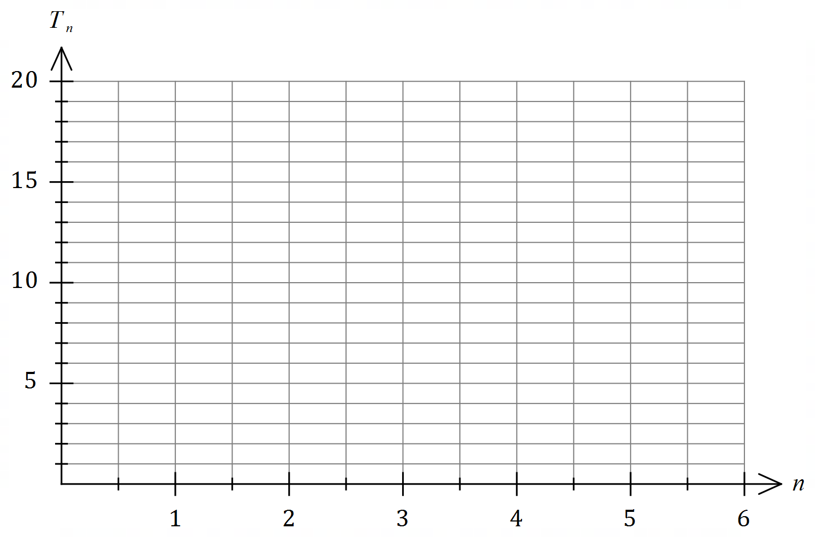

(d) What feature of the graph indicates that the sequence is arithmetic? (1 mark)

Question 3 (6 marks)
(a) Connected planar graph $G_{1}$ has $2$ vertices and $5$ edges.

(i) Use Euler's formula to determine the number of faces in $G_{1}$. (2 marks)

(ii) Sketch a possible graph $G_{1}$. (2 marks)

(b) Graph $G_{2}$ has $4$ vertices and is Eulerian. The length of the Eulerian trail is $6$. Sketch a possible graph $G_{2}$. (2 marks)

Question 4 (7 marks)
A recent survey asked people their age and the question "How often do you feel lonely?". The responses for the age groups $16\text{-}24$ years and $65\text{-}74$ years are shown below. The categories in the key are shown from left to right in the stacked percentage frequency graph.

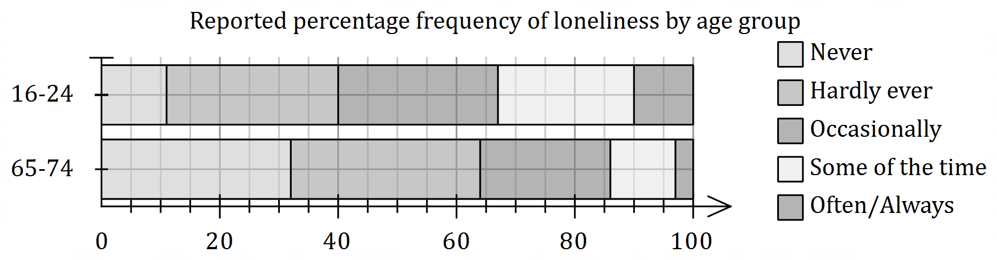

(a) State the second largest category for the $16\text{-}24$ age group. (1 mark)

(b) State the percentage of those

(i) in the $16\text{-}24$ age group who responded with 'Some of the time'. (1 mark)

(ii) in the $65\text{-7}4$ age group who responded with 'Hardly ever' or 'Occasionally'. (1 mark)

(c) Use the graph to explain why the data suggests an association exists between feeling lonely and age. (2 marks)

(d) Briefly discuss non-causal explanations for the observed association. (2 marks)

Question 5 (6 marks)

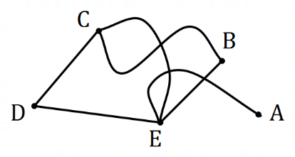

Graph $G$ is shown. $G_{1}$ and $G_{2}$ are subgraphs of $G$, so that each subgraph has $5$ vertices but one less edge than $G$.

(a) $G_{1}$ does not satisfy Euler's formula. State which edge must be removed from $G$, and show that $G_{1}$ does not satisfy Euler's formula. (3 marks)

(b) $G_{2}$ is bipartite. State which edge must be removed from $G$, and draw $G_{2}$ to clearly show the partite sets. (3 marks)

Question 6 (7 marks)
The scatterplot below shows the number of PC's per $100$ people on the $x$-axis and the
unemployment rate, as a percentage, on the $y$-axis for a selection of countries in $2016$.

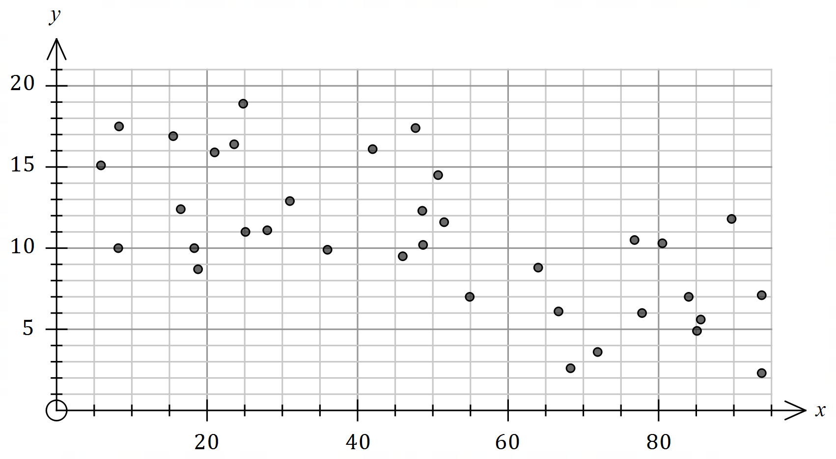

(a) Describe the strength and direction of the association between the variables. (2 marks)

(b) The equation of the least-squares line for the data is $y=15.8-0.11x$. Interpret the intercept and the slope of this line. (3 marks)

(c) A newspaper article used the graph to claim that increasing the number of PC's per person in a country caused the unemployment rate to fall. Comment on this claim.
(2 marks)

Question 7 (7 marks)
In a set of $5$ pages on a website, there are hyperlinks from page $1$ to page $2$, from page $2$ to
page $5$, from page $3$ to page $1$, from page $4$ to pages $2$ and $3$, and from page $5$ to page $4$.

(a) Construct digraph $D$ to show the above information, where pages are represented by vertices and links by directed edges. (2 marks)

(b) Construct an adjacency matrix for $D$. (2 marks)

(c) List, starting at page $5$ and in the order visited, vertices in $D$ that form a

(i) walk of length $2$. (1 mark)

(ii) cycle of length $3$. (1 mark)

(iii) trail of length $4$. (1 mark)

Question 8 (7 marks)
Every day, $10\%$ of the water in a tank is drained for crop irrigation and then the tank is topped up with $40$ kL of water. The tank has a maximum capacity of $350$ kL.

At the start of Day $1$, before water is drained for the crops, the tank contains $50$ kL.

(a) Determine the amount of water in the tank at the start of Day $2$. (2 marks)

(b) Determine a recursive rule for the amount of water, $A_{n}$, in the tank at the start of Day $n$.
(2 marks)

(c) Explain why the tank will never empty. (1 mark)

(d) State, with justification, whether the tank will overflow. (2 marks)

Supplementary page

Question number: _________

© 2020 WA Exam Papers. Kennedy Baptist College has a non-exclusive licence to copy and communicate this document for non-commercial, educational use within the school. No other copying, communication or use is permitted without the express written permission of WA Exam Papers. SN245-156-1.

